PENNHURST

Sitting high atop Crab Hill, about one mile northwest of the town of Spring City, there once was a sprawling community that encompassed over 1400 acres of prime Chester County farmland and had a magnificent view of the winding Schuylkill River. That community in its final years was known as “Pennhurst Center”. The Pennhurst State School and Hospital was opened in 1908. At the time of its opening it was referred to as the Eastern Pennsylvania Institution for the Feeble Minded and Epileptic. Pennhurst officially came into existence with an act of the state legislature in 1903 and opened its doors in 1908. It was during this time that many postcard views showing the new facility were published. All of the buildings had a name and a corresponding letter designation. The hugh complex of red brick buildings included building P the Administration building, hospital buildings, patient wards, a laundry, a cafeteria, a movie theater, and a power house. There were separate resident houses found on the grounds for the administrator, doctors and other higher ranking staff. There were numerous farms including a dairy farm, a pig farm and a hennery. There were greenhouses and a large garage with a fleet of state vehicles. Pennhurst had its own disposal plant, reservoir and giant water tower. Many of us still remember seeing the bright shining star on top of the old tower that was always lit during the holiday season.

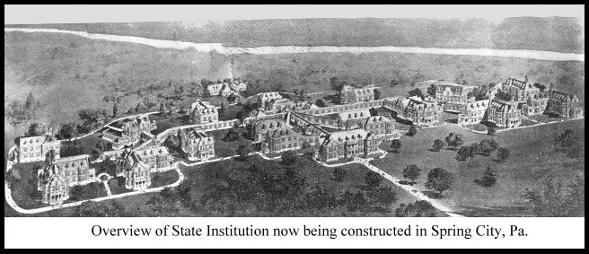
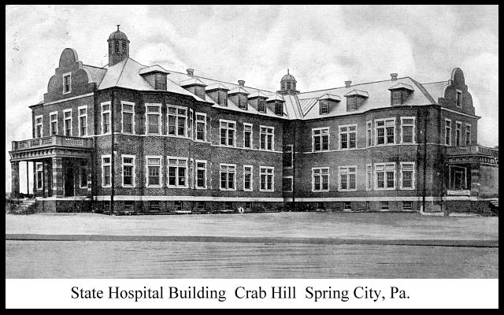
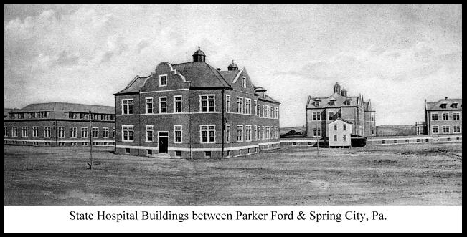
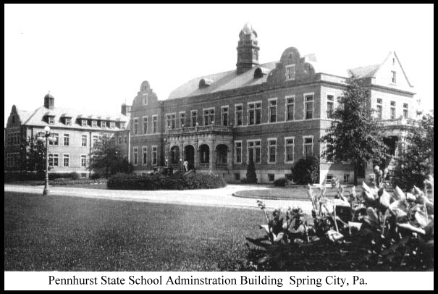
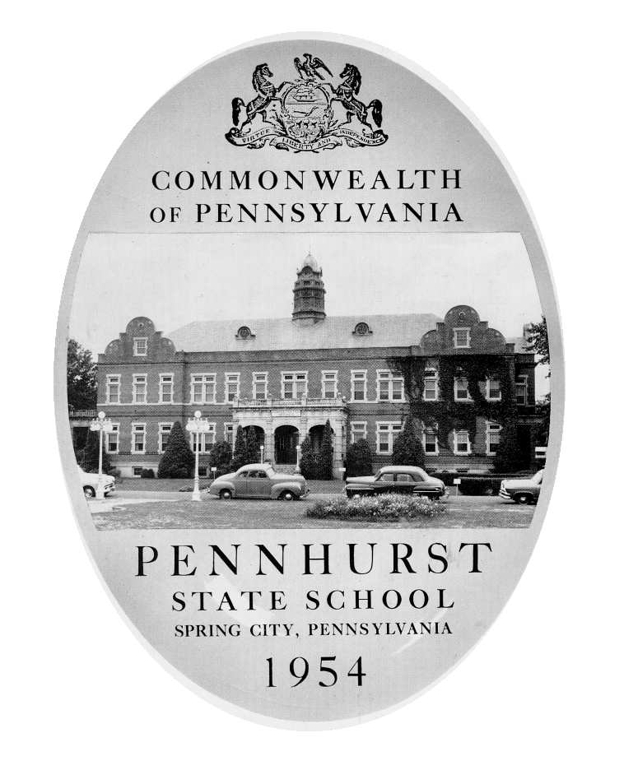Pennhurst was in relative terms a very large facility, and in 1954 had over 3550 patients and 575 employees. The number of residents would make it larger than the borough of Spring City and yet to many it remained obscure. My first years in Spring City were in the fifties and the one thing that I recall seeing was a marching band from Pennhurst participating in a local parade. In tenth grade our local Boy Scout group visited the Boy Scout group from Pennhurst. I remember walking along this long underground tunnel. It was damp and smelled. All of the main buildings on the lower campus are connected by these tunnels and you could travel all about and never see the light of day.

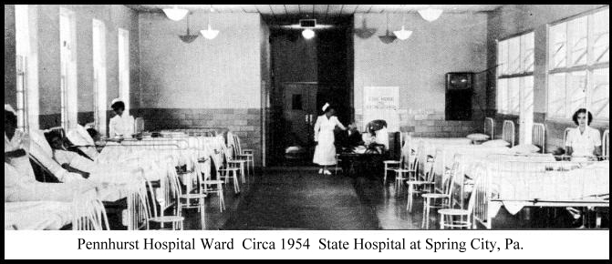
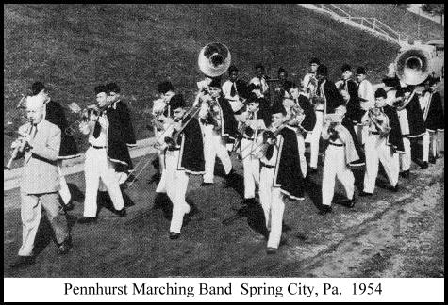
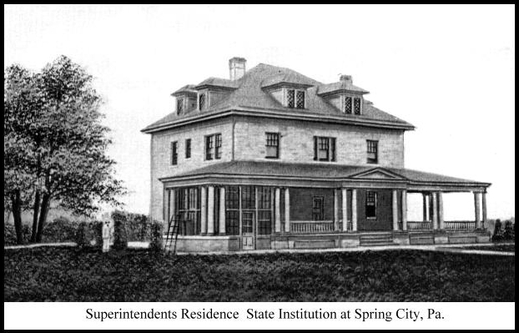
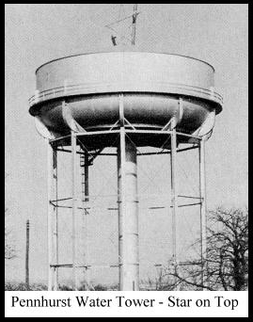
In the early days the Pennhurst State Institution operated as a self sufficient facility and actually made a profit for the state. Can you imagine anything that the government is involved with not costing you money? Many of the higher functioning patients were working and doing the day to day chores necessary to run the institution. There were many shops such as the upholstery shop, the sewing shop, the mending shop, the weaving and printing shops. There were the housekeeping and patient care helpers, as well as kitchen workers, the butcher shop and the bakery aides.

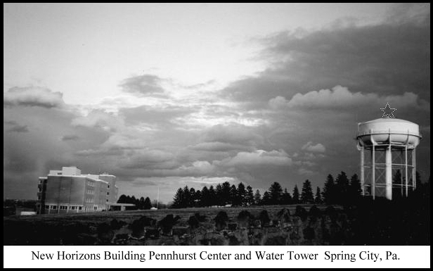
As the times changed so did the isolated community of Pennhurst. Patients were referred to as residents and eventually clients. Many people considered it nothing more than a warehouse for the mentally retarded. The state employees eventually unionized and the outside world became involved with the inner workings of the state hospital. Many felt it was forced labor to have clients work. In the end all jobs were preformed by paid employees. In the late 1980’s Pennhurst closed with many of the clients being placed in group homes and other state facilities.
Today in 2004 much of the former Pennhurst property and buildings on the lower campus are sitting exposed to the elements as mother nature chisels away at the remains. Further up the hill sits the New Horizons Building which was the last permanent brick structure constructed at Pennhurst. Today this building is part of the Veterans Center and has been completely renovated.
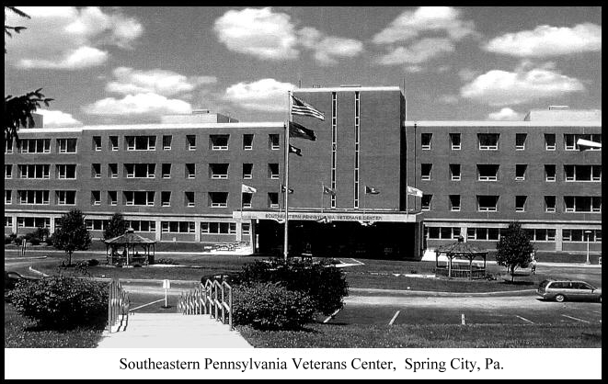

W. C. Brunner

